* Requirements:

|  |  |  |  |  |  |  |
| --- | --- | --- | --- | --- | --- | --- |
| Status | Risk | Priority | Description | F/NF | Module | ID |
| DONE | LR | MH | The system needs to be able to open supplier account | F | Suppliers |  |
| DONE | LR | MH | The system must manage for each supplier the necessary details: account number, bank account, payment agreement, save contacts and their contact Information | F | Suppliers |  |
| DONE | HR | MH | The system must manage the items which each supplier can supply with their price and catalog number at the supplier | F | products |  |
| DONE | HR | MH | The system must save for each product of the same supplier a unique catalog number | NF | products |  |
| DONE | HR | NTH | The system may give discount for a supplier base on the number of products in order | F | Orders |  |
| DONE | HR | NTH | The system may give discount for a supplier base on the number of specific products in an order | F | Orders |  |
| DONE | HR | MH | The system must be able to create a new order from a supplier | F | Orders |  |
| DONE | LR | MH | When open an order the system must save the creation date | NF | Orders |  |
| IN PROGRES | HR | NTH | The system should transfer the order details to the supplier's system | F | Orders |  |
| DONE | LR | MH | The system needs to save for each order who is the deliver, "Super Li" or the supplier | F | Delivery |  |
| IN PROGRES | HR | NTH | The system needs to support payment to the supplier by cash and credit card | NF | payment |  |
| IN PROGRES | HR | NTH | The system needs to support immediately payment and payment one month late | NF | payment |  |
| DONE | LR | MH | The system needs to be able to save for supplier Fixed delivery days. | F | Delivery |  |
| DONE | HR | MH | Supplier that has a fixed delivery days the system must able the client to update the items list before each delivery. | F | Delivery/  Orders |  |
| IN PROGRES | HR | NTH | If the client didn't update the items list to supplier in fixed delivery days, the system will open order with the same items of the previous order. | F | Delivery/  Orders |  |
| DONE | LR | NTH | The system should save all the past orders | NF | Orders |  |
|  |  |  |  |  |  |  |

* Open Questions:

|  |  |  |
| --- | --- | --- |
| Issue | Topic | # |
| If the system needs to save the type of the supplier? | type |  |
| If the system should work on Saturday? | Generic |  |

* Close Questions:

|  |  |  |  |
| --- | --- | --- | --- |
| Our decision | Questions | Topic | # |
| Cash or credit card | How the system will pay on order to supplier? | Payment |  |
| In the Storage office. | Where the system will be in use? | Use of the system |  |
| No, because the system install in the Storage. | If the client need to login in the model? | Login |  |
| First, calculate on the amount of product and then add the discount on the numbers of items in the order | How the system calculate discount? | Discount |  |

דרישות שלא מומשו ולמה?

* דרישה 9: לא מומש, כי לא היה ידוע איזה מערכת יש לספקים השונים או איך צריך להתבצע החיבור למערכות הספקים השונים.
* דרישות 11-12: לא מומש כי כרגע אין זמן ומשאבים ללמוד ולפתח התממשקות למערכת אשראי.
* דרישה 15: לא מומש כי המערכת כרגע סטטית וקשה לעשות משהו שיקרה באופן אוטומטי בלי בקשה של המשתמש, וגם חסר לנו החיבור למערכות הספקים.
* Class Diagram:
  + 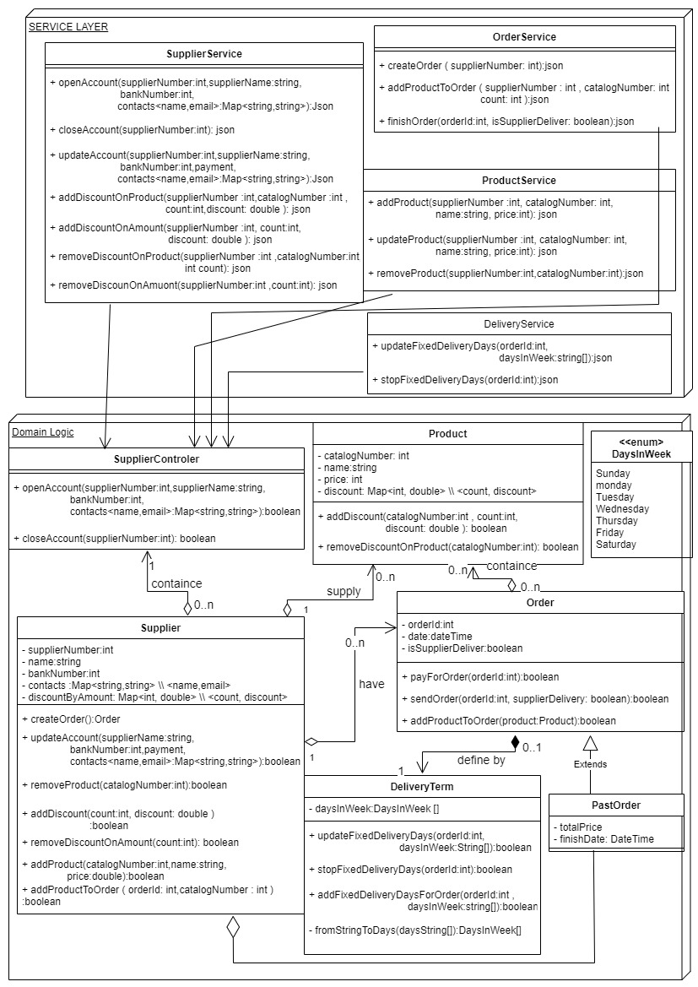Service – domain:
  + 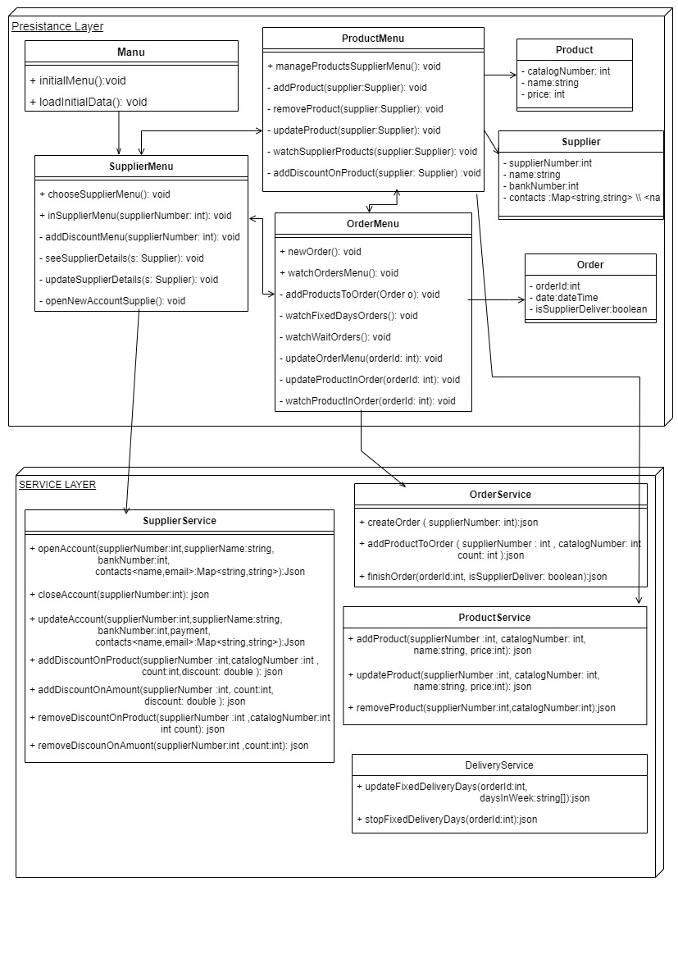Service – persistence:
* Object Diagram 1:

תרחיש: יש במערכת 2 ספקים ושניהם מציעים לספק מוצר שעון, במחירים שונים עם מספר קטלוגי שונה.

לספק קסיו יש הזמנה 1 שהסתיימה ועוד הזמנה קבועה של השעון שמסופקת כל שבוע ביום שני.

כרגע המחסנאי בתהליך של ביצוע הזמנה מהספק "קסיו".

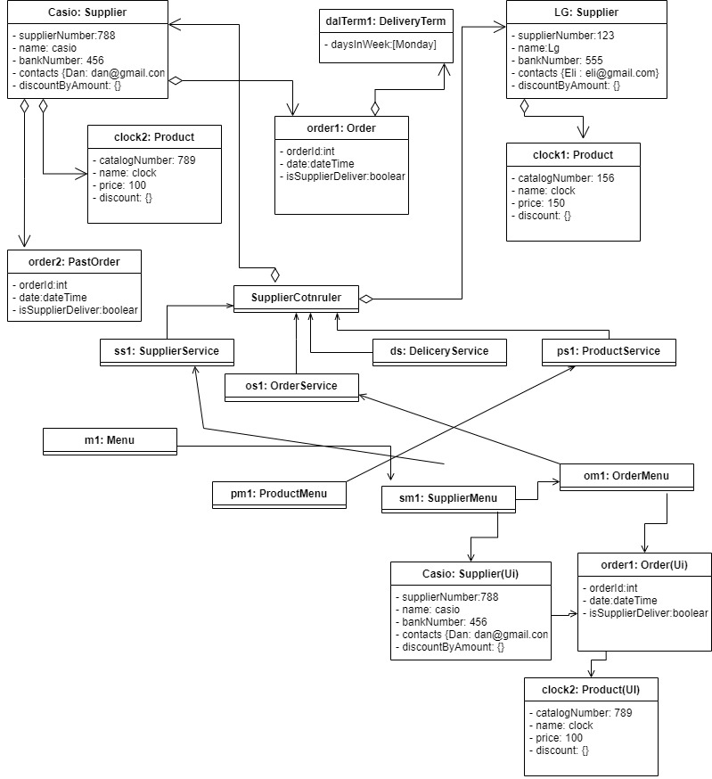

* Object Diagram 2:

תרחיש: במערכת יש ספק 1 : "פיילוט" שלו יש 3 פריטים: עט, עפרון, סרגל.

בלי הזמנות, המחסנאי כרגע מגדיר את הספק והפריטים שלו במערכת.

